All Purpose Waterproof Blanket

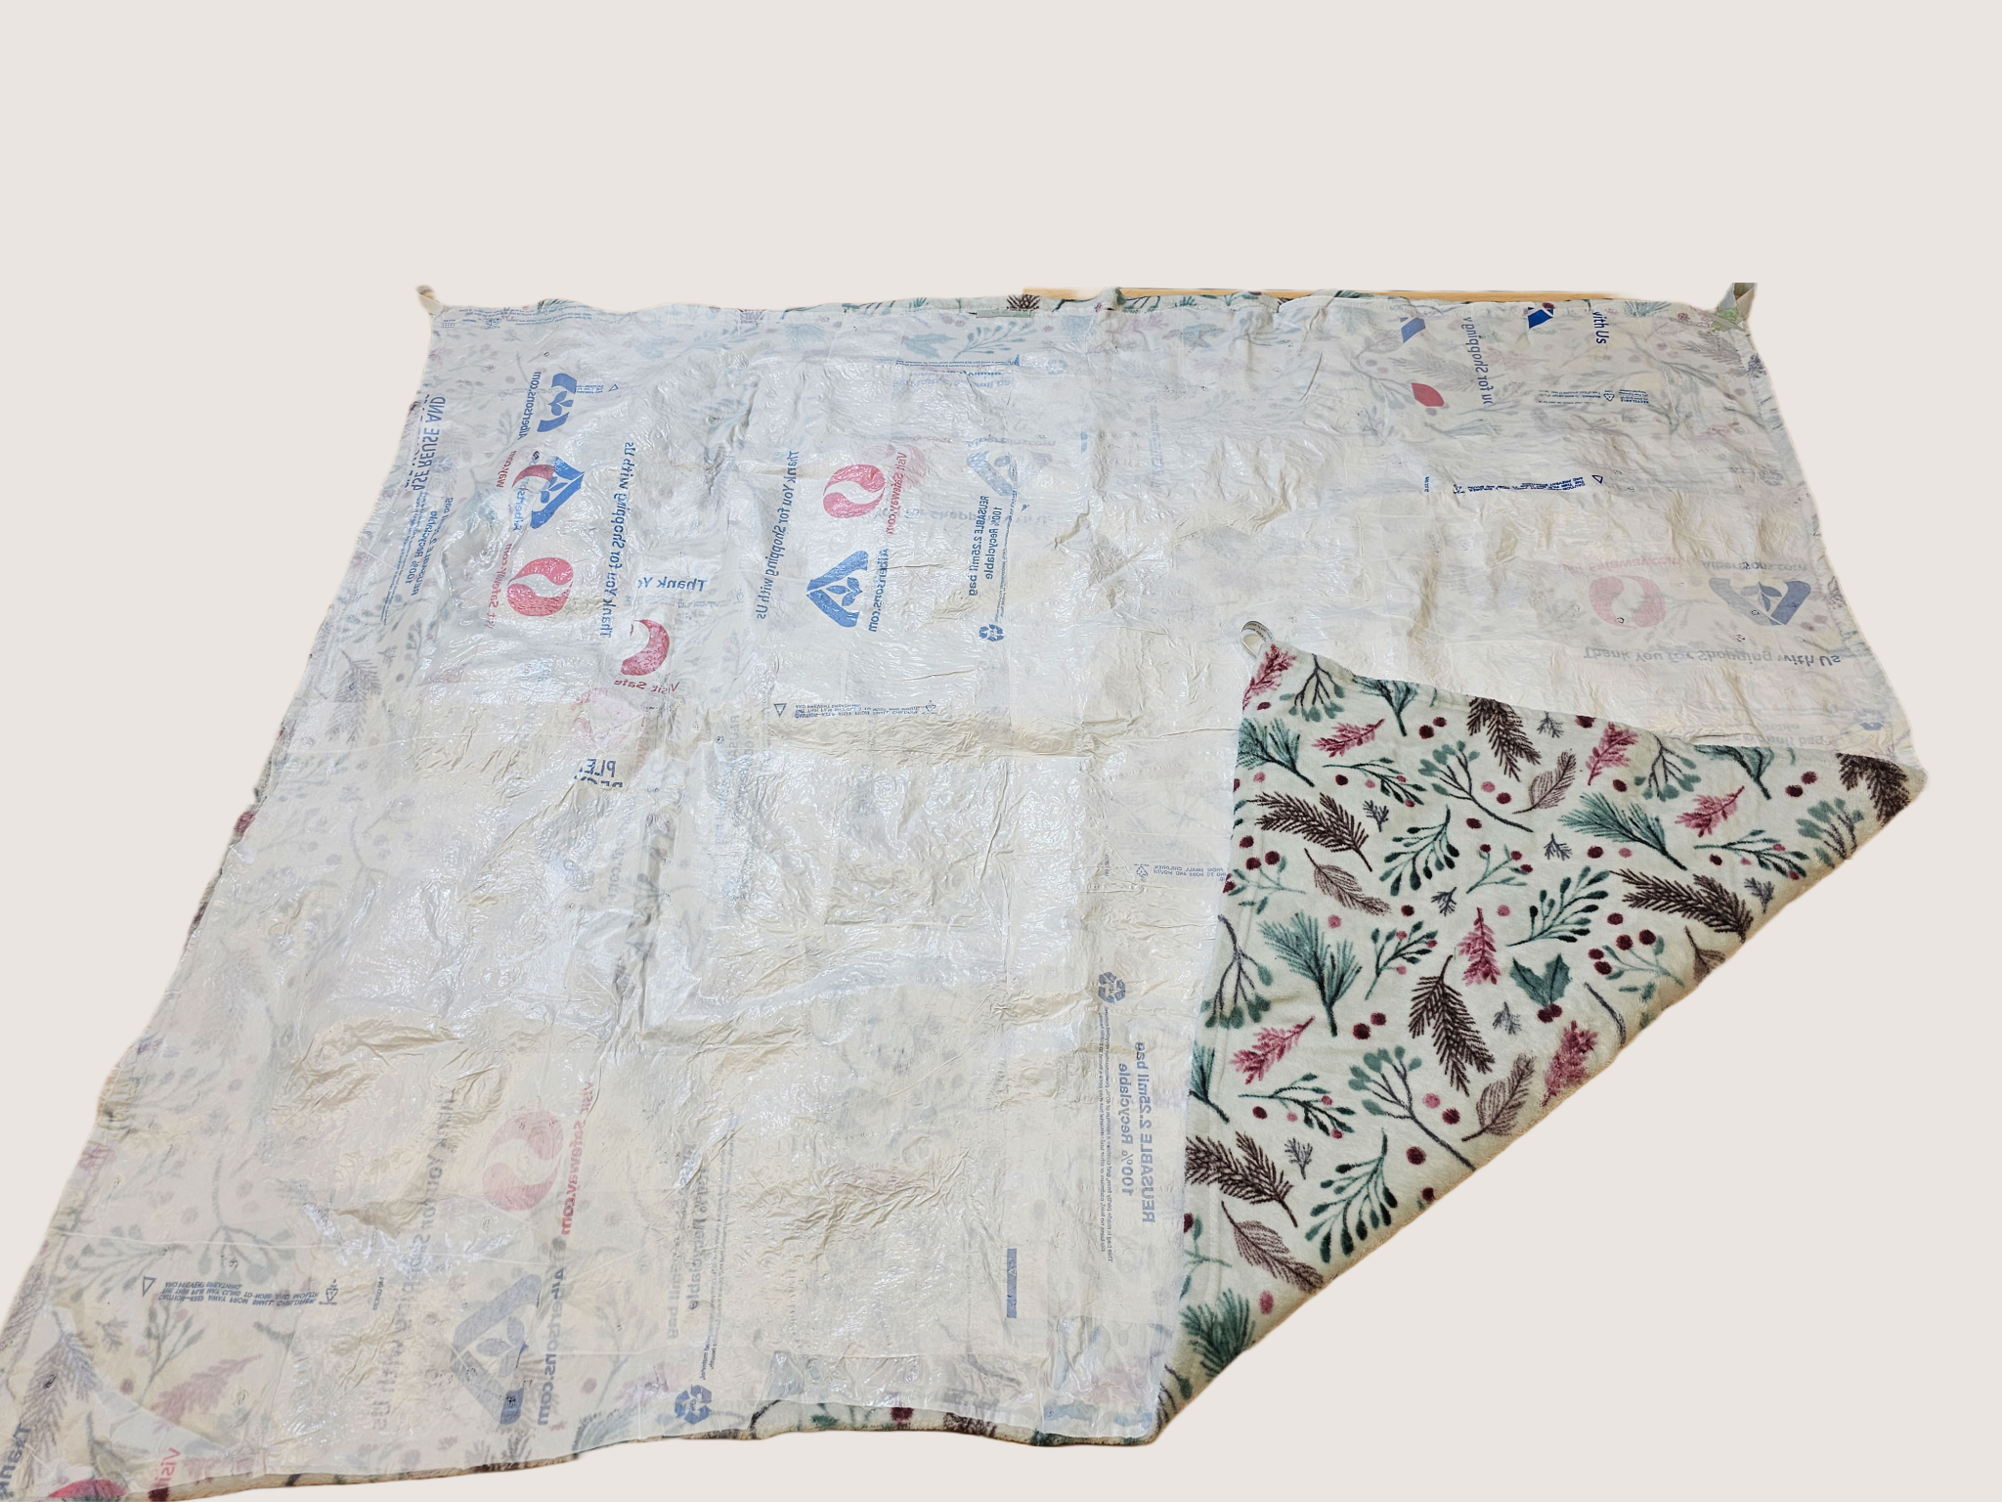

Are you overwhelmed by an excessive amount of grocery bags at home and don't know what to do with them? We have the best solution for you. This user guide provides step-by-step instructions on how to repurpose plastic bags into all purpose waterproof blankets. By reusing plastic bags, you can contribute to reducing waste and creating a functional and eco-friendly waterproof blanket for various purposes like picnic blanket, rain shelter etc. Follow the instructor below to create your very own waterproof blanket for any purpose.

Table of Contents

03 Warning/safety and precautions

4-5 Tools/ Materials needed

07 1.1 Selecting your blanket

08 1.2 Laying out your work station

09 1.3 Selecting and preparing your bags

08 Step 4: Attaching Plastic Bags to the Fabric

09 Step 5: Heat Treating Process

10 Step 6: Layering

11 Customization of Blanket (Optional)

12 Blanket Upkeep/ Patching Repairs

13 Troubleshooting

14 FAQ



Safety is the most important thing considering the numerous hazards around us. It is crucial to take everything into account. This project is user friendly, hovewer we have a few things to highlight.



1. Adult supervision for children 8+

Be careful while using the iron, as it reaches higher temperatures. If a child is involved in this project parents must assist them. There will be dangerous tools used, such as iron and super glue.

1. The type of plastic bags that will be melted

Plastic bags are made of different types of materials. The ones that are not safe to burn and are known to cause cancer are 1(PETE), 3 (PVC), 6 (Styrofoam), and 7 (Misc). For more information, view this video below:

[Precious Plastic - Safety and plastic fumes (part 2.2)](https://youtu.be/bsj6qHHLynk)

1. A solid heat resistance surface required

You will use heat to melt the plastic bags. Therefore, it is important to make sure that the surface you will use can handle heat. We recommend using an ironing board. 

1. A well ventilated area recomended

Even though some plastic bags materials are labeled safe to burn, it doesn’t mean that they are completely safe. Rather, they are the least harmful compared to other plastic bag materials. Therefore, ensure that you are in a well-ventilated area to avoid any harm before starting the project.

Tools/Materials Needed

Here are all the materials and tools that you need to complete this project. We also provide alternative ways to reduce the cost of tools and materials. If you follow the alternative way to reduce the tools and material price, you can make the project cheaper from $34.14 to $11.23. You are free to choose any way to get the tools and materials.

| TOOLS/MATERIALS | AMOUNT | PRICE | ALTERNATIVE WAYS TO REDUCE THE PRICE |
| --- | --- | --- | --- |
| Iron Stand | 1 | $9.88 | Can use a table or any flat surface to replace an iron stand. |
| Iron | 1 | $10.36 | Can use your own iron at home if you have one. |
| Scissors | 1 | $2.24 |  |
| Parchment Paper | 1 | $2.67 | Can use any old T-shirt you do not want to replace parchment paper. |
| Plastic Bags (HDPE) |  | $0.00 | You can likely use the plastic grocery bags you have at home, just ensure that they are made of High-Density Polyethylene which most grocery bags are made of (HDPE). Bag identification info can be found in step 3. |
| Superglue | 2 | $4.99 | The amount of superglue you need depends on the use of it we use two, for you it may take less or more. |
| Blanket | 1 | $4.00 |  |
| **TOTAL** |  | $34.14 |  |
| **REDUCED ALTERNATE TOTAL** |  |  | $11.23 |

Step 1: Selecting your Blanket

This process is the most crucial to the outcome of your final product. It is recommended that you choose a blanket that you do not use often or value greatly. This is because if you decide that you would like to remove the plastic layering, it will cause damage to the underlying fabric. When selecting a blanket, there are a few important things to keep in mind:

1. Look for the fiber composition tag on your blanket.

These are often located on one of the four corners of your blanket and will let you know the type of material you will be working with. We recommend using (What type of fabric?

1. Different fabric blends will interact differently with the plastic melting process:
   * Natural fibers such as cotton and wool have higher heat resistance, and allows for better adherence of plastic bags to the surface.
   * Synthetic fibers such as acrylic, nylon, or spandex should be avoided whenever possible. This is due to their relatively low melting temperature, and potential chemical interactions that may occur during the gluing process.
   * While synthetic, polyester is a perfectly safe material to use for this process, just make sure that your iron does not heat higher than 295°C as the blanket has a chance of melting.
2. Make sure to wash the blanket before attempting this project:
   * Dirt and dead skin will make it more difficult for the plastic to adhere to the blanket
   * Contaminants like soap or oil will make it more difficult for the plastic to adhere, and may burn off under high heat, resulting in smoke.

Step 2: Laying out your Workstation

Now that you have your blanket selected, you’re going to need a place to work on it! Luckily, you can make a workstation for this process nearly anywhere! By prepping your materials at your desired location using the following guidelines provided below, you can be sure that you are as prepared as possible to follow the project’s later steps!

* Find a good ventilate space and fan
* Fire extinguisher
* Outlets
* Gather all the materials and make a space for them
* Cut a piece of parchment paper

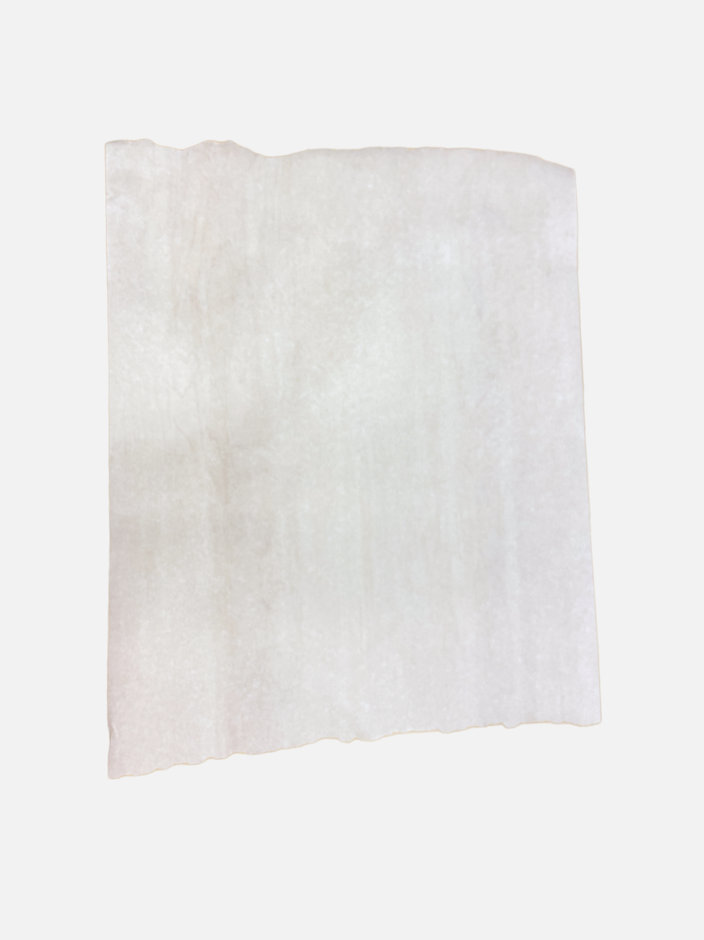

* Protect the surface or table in which your are going to work with old cloth or parchment paper .

Now you are ready to start the process!

Step 3: Selecting and Preparing Your Bags

With your now prepped workstation containing a large flat area, and a pair of scissors, it’s finally time to modify your materials. In this section, we will cover not only how to find suitable bags for your blanket but also how to prepare them for the heat-treating process that adheres the two. By following these steps, you can be assured that your bags will have the best chance possible of sticking to your blanket.

* There is a crucial step that is required during the selection process that **cannot** be overlooked. Different plastic bags may have different compositions depending on where or when they were manufactured. In order for this project to work, you must ensure that your bags are made from **high-density polyethylene (HDPE).** The plastic type can be identified by looking for a triangle symbol made up of arrows, with a number in the middle. HDPE can be identified by the number **2.** If your bag has any other number designation, **DO NOT USE IT**. By using any other number, the provided instructions for this project will be inaccurate, potentially resulting in personal injury from molten plastic, fires, or carcinogenic vapors.
* Gather a sufficient number of clean and dry plastic bags.10-15 bags is sufficient The number will depend on the desired size and thickness of your picnic blanket. It's best to choose bags of similar thickness and size for consistency.
* Remove any labels or stickers from the bags.
* Flatten each plastic bag by smoothing out any wrinkles or folds. Ensure they are free of any moisture.
* Now start cutting the plastic bags: Use scissors to cut off the handles, bottom seam, and side seams of the bags. Cut along the bag's seam lines to create large plastic bag sheets.

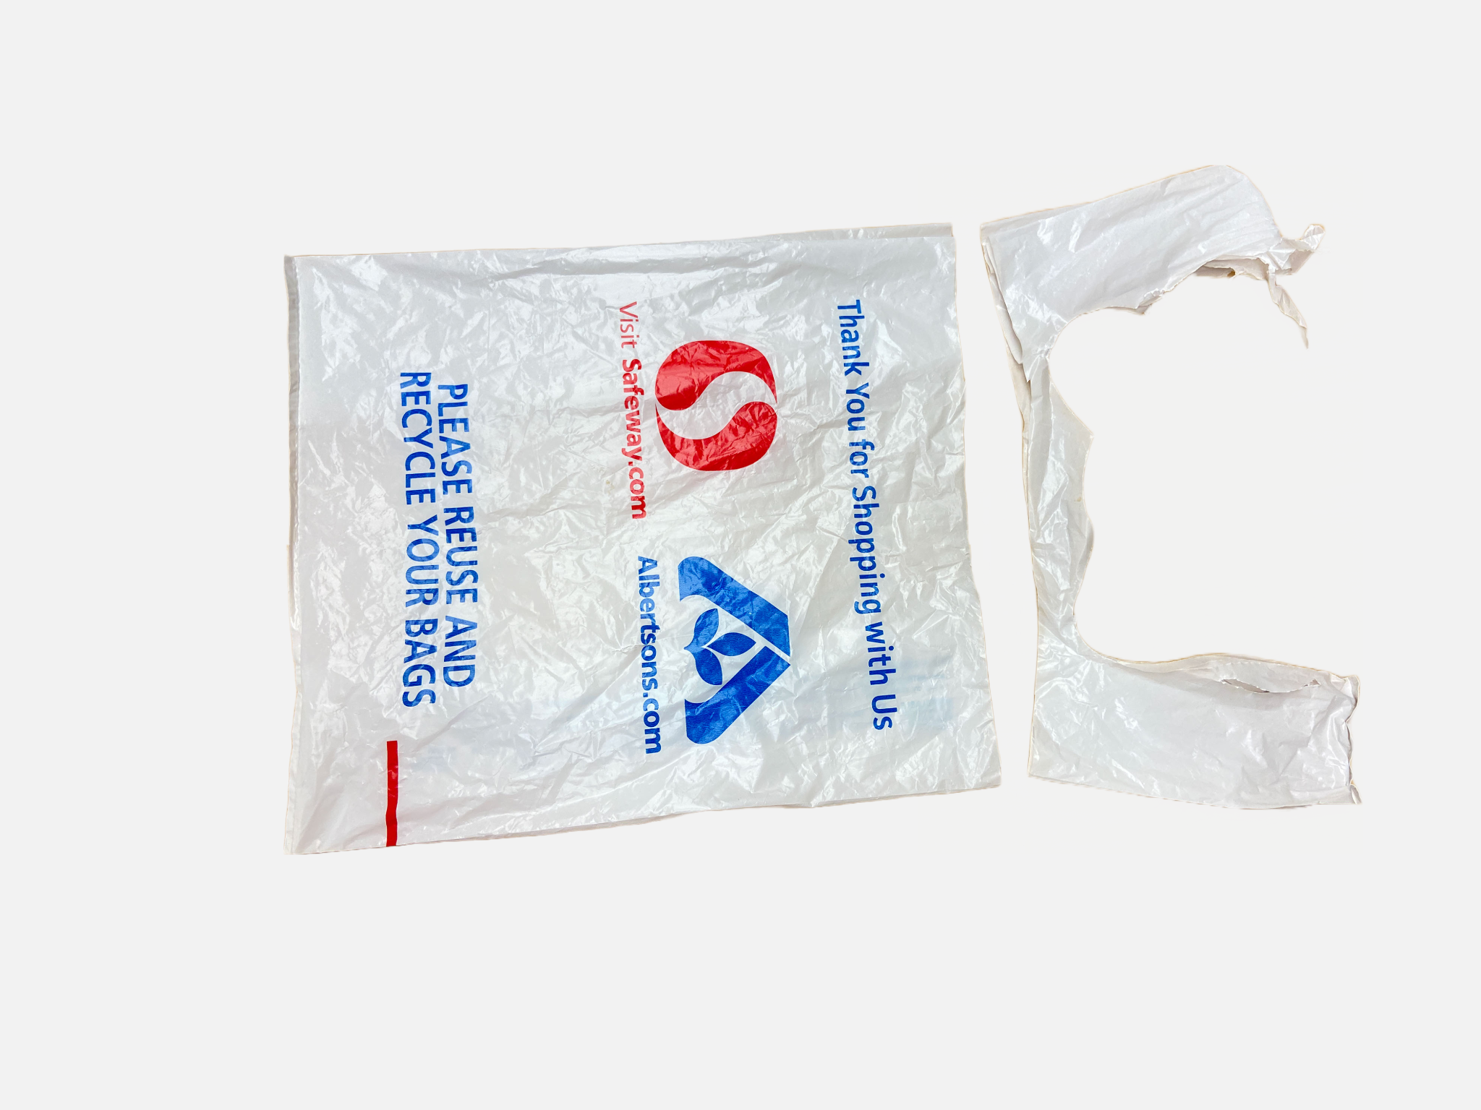

Step 4: Attaching Plastic Bags to the Fabric

⚠️**Super glue sticks to skin instantly, wear gloves and exercise caution, especially when children are present!**⚠️

With bags cut to length as specified above, you should now be ready to join the two together for the very first layer. Through our testing, we found that using a hot glue gun was less effective than super glue both in application time, and glue strength. However, it is important to note that while natural fibers may have no interactions, synthetic fibers may chemically react with the solvents in the glue. Should you find this happening, please read the troubleshooting guide at the end of this document. A note for parents: while super glue only poses a minor risk of injury, please keep your children under close supervision if you do not take over for gluing.

Before melting the plastic bags to the blanket we will use super glue to attach and reinforce the first layers of plastic bags to the blanket. Note: (There are different methods to secure the plastic bags to the fabric, glue gun is also a great option if you have it already at home however it slows down the process) We recommend using super glue as the best and easy option for attaching the plastic bags to the blankets before melting.

1. For the first layer put a very small drop of super glue on the back side of the blanket then put the plastic bag on immediately as you apply the glue overlapping the edges slightly. Ensure that the entire surface of the blanket is covered, leaving no gaps between the plastic sheets.
2. Adding too many drops of super glue on one area will cause the extra glue to leak to the other side of the blanket and will stick on the surface.
3. Super glue will dry fast, so you need to add the plastic bag on top of it fast. If you do not put the plastic bag fast, the super glue will dry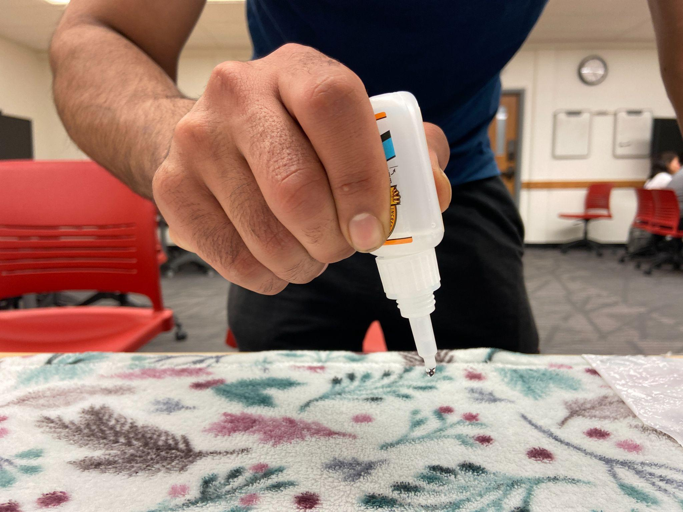

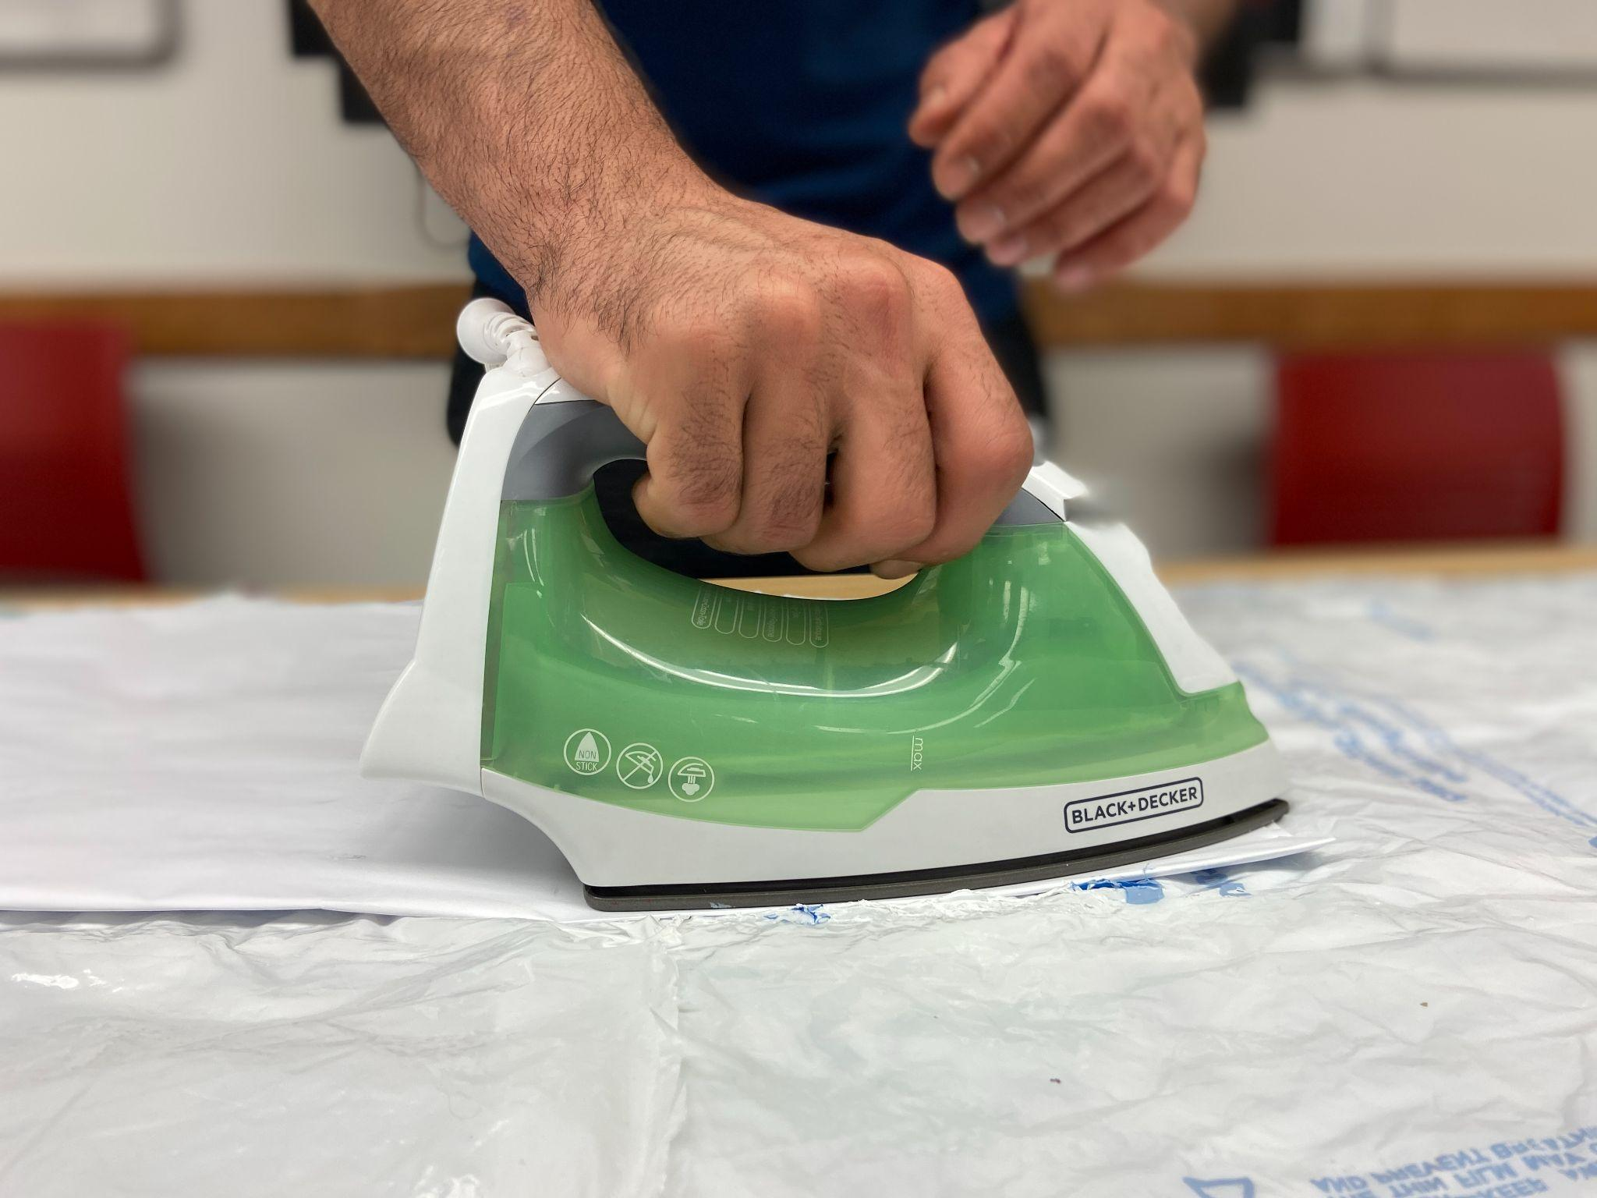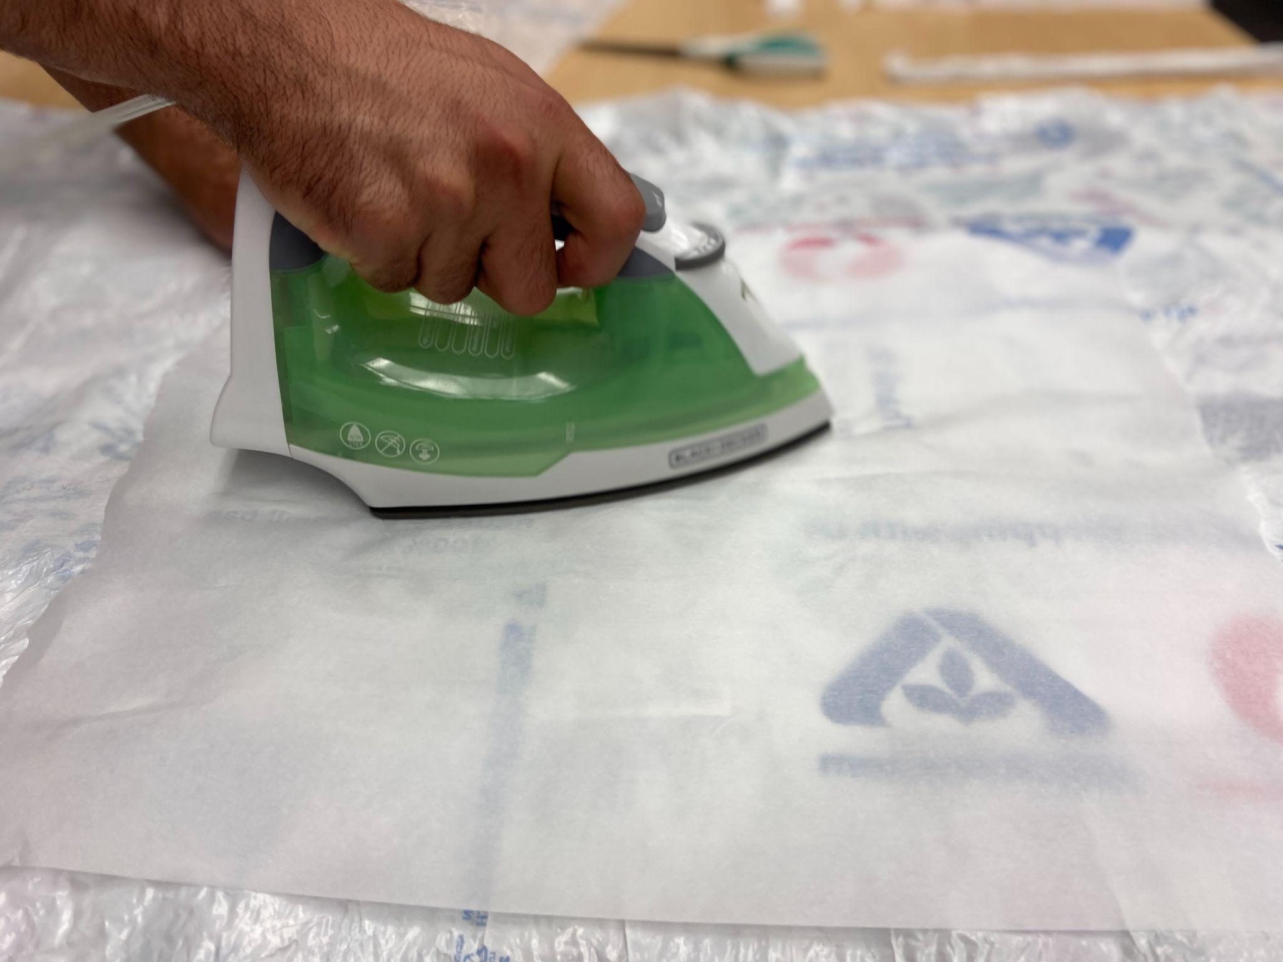

Step 5: Heat Treating Process

⚠️**All steps past this point involve a hot iron and molten plastic. Children under 10 years old should NOT handle these items directly. Anybody touching the iron or blanket should wear gloves and double check the workstation is properly ventilated. It is also recommended to have a fire extinguisher nearby.** ⚠️

Now that you have finished your gluing, as detailed above, you should have your whole blanket covered in a layer of slightly overlapping plastic. The plastic seems a little wrinkly, not clinging to the blanket well enough to protect you from the harsh ground. However, this is only temporary and will be resolved by heating up the HDPE plastic to a malleable temperature, allowing it to flow and lock into the blanket. By following the steps listed below, you can ensure a quick, safe, and effective heating of your blanket and plastic material.

1. Preparing the Iron: Too high a setting could potentially melt the plastic bags too much, compromising their structure. A setting too low might not provide enough heat for the bags to attach properly to the blanket.
2. Safety Preparations: This acts as a protective barrier between the iron and the plastic, preventing the bags from melting onto the iron.
3. The Heat Treating Process: Glide the iron over the parchment paper or cloth, evenly distributing the heat across the entire surface of the blanket. Keep the iron moving continuously for about 1-2 minutes, paying special attention to the edges to ensure full adhesion.
4. Checking the Adhesion: Once you have completed the initial heating, check the edges and corners of the blanket to confirm that the plastic bags are securely adhered. If any areas are loose, repeat the heat treating process on those specific spots.
5. Cooling Down: Let the blanket cool down after the heat treatment. This cooling period is essential as it allows the super glue to cure and harden, thereby ensuring a durable bond between the plastic bags and the blanket.

This initial heat treatment prepares the blanket for the next step of the process - layering. Layering will involve attaching more plastic bags using the same glue and heat process, creating a thicker, more insulating layer.

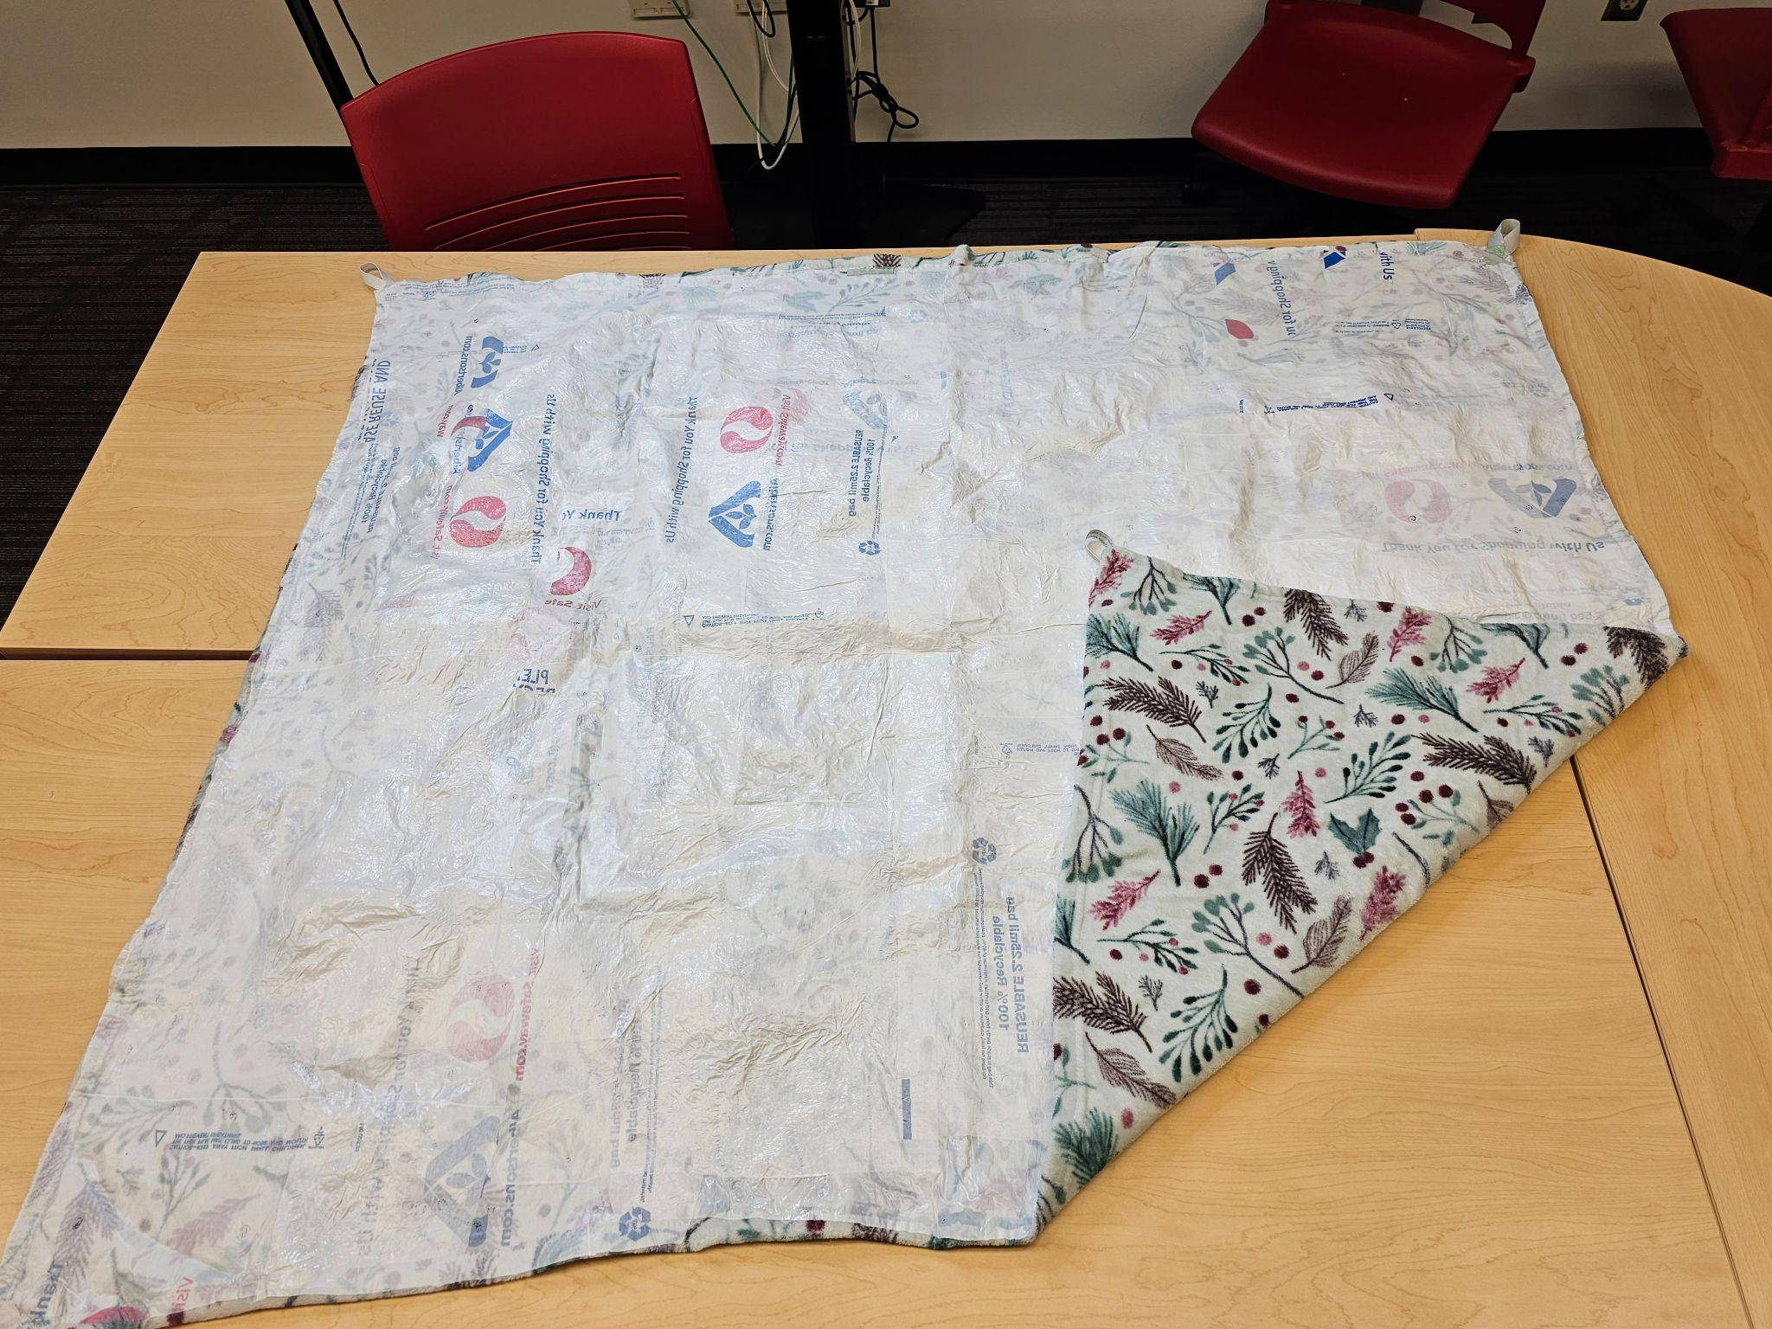

Step 6: Layering

By now, your blanket should be freshly iron-warm, and your first layer will have fused itself nearly seamlessly to your blanket. Your plastic layers may have shrunken slightly, leading to tiny holes. In order to ensure that your blanket is resistant to rough surfaces while also remaining waterproof from the bottom, you will need to add more layers. This process does not require any more superglue and will take significantly less time and effort than the previous process. By following the steps below, you can be assured that your plastic layer will be as resistant as possible!

For this step, we will use the iron to attach the second and third layers of plastic bags to the blanket.

1. Once the first layer is done, add the second layer of plastic bags on the blanket and lay out a parchment sheet or an old cloth on top of it.
2. Next, just put the iron on top of the parchment sheet and start ironing for about 1-2 minutes, making sure that the iron is constantly moving.
3. If you do not use a parchment sheet, the plastic bag will melt completely and will stick to the iron instead of the blanket.
4. Check the edges of the blanket and make sure that they have attached to the blanket.
5. Be cautious not to overheat the plastic. Putting the iron over a spot longer than needed will cause the plastic bag to melt completely and will start to shrink.
6. Repeating the process

Repeat the process of step 1 and 2 for creating the third layer of plastic bags. Continue ironing until the bags fuse together uniformly.

Customization of the Blanket

One of the top selling points for this project is the sheer amount of creativity that you can impart to your individual blanket. Since HDPE plastic fuses together almost seamlessly at high heat, you can modify your design however you want! An excellent example of customization would be adding four plastic loops to the corners of the blanket so that it can be staked down into the grass for better wind protection. The process for this modification is as follows:

1. Cut 1-2” strips from your plastic bags, and layer them on top of each other to form 1 thick individual strip. To ensure that your material can withstand stress and strain, make sure you have at least 16 layers.
2. Cut a large sheet of parchment paper and then fold it in half. Unfold your parchment paper and then stick your plastic layers between the paper's top and bottom sections.
3. Once the parchment sheet is closed with your material in between, use your iron on the sheet, applying pressure until the material is hot and fused together.
4. Cut your new layered plastic material in half lengthwise and widthwise, leaving you with four individual strips.
5. Connect the ends of each strip together, creating a loop shape. Put this loop shape in the parchment paper, and press down with the iron until the plastic fuses into its new form.
6. Place each loop onto each corner of the blanket, and prepare a few small squares of extra plastic bag that you will use to help secure the loop to the blanket. Place these extra squares right on top of where the loop makes its connection with the blanket’s plastic.
7. Using a sheet of parchment paper on top of your loop and square assembly, press the iron to melt and attach your loop to the corner. Repeat for all four corners.

While the customization process here only regards creating loops for tent stakes, this process should work for any modification you wish to add to your blanket. By cutting, layering, and melting plastic into different forms, you have virtually limitless options to change the way that you would like your blanket to look.

Blanket Upkeeps/ Patching Repairs

Sometimes we make mistakes and here is what to do to:

* If you accidentally melted the plastic bags too much, they will start to shrink and holes will appear. To fix that issue, simply add a small piece of layer of plastic bag where the holes are and melt it properly, and you are all set!

Generally, you can keep adding layers of plastic bags to repair holes or torn parts of the blanket! In other words, your blanket is infinitely repairable!

Troubleshooting

| PROBLEM | SOLUTION |
| --- | --- |
| The plastic pulls apart from the blanket really easily: | You likely have not sufficiently glued the plastic sheets to the blanket’s surface. Increase the density of glue spots around the trouble areas. |
| The heat from my iron caused the blanket to melt: | While very uncommon, this phenomenon can occur should you have a high nylon or acrylic content in your blanket. We recommend finding a different blanket or turning your iron onto its lowest setting if you cannot. |
| Smoke during the heat-treating process: | Under normal circumstances, this should not happen with HDPE plastic. If you see smoke, this likely means that there may be a thin layer of contaminant (oil, dust, food residue, etc.) on your bags' surface. Make sure that your bags are properly cleaned and dried before starting the project. |
| The plastic keeps sticking to the iron: | If the plastic makes contact with the hot iron directly, it will stick nearly instantly. Ensure you have cut your parchment paper sheets big enough for your working area, and ensure your iron does not slip from it at any point. |
| Plastic edges are loose, or plastic is not fusing together: | First, make sure that your iron is plugged in and getting power. If your iron is plugged in, set it to a higher temperature setting and try again, making sure to apply hard pressure to the blanket. Should none of this fix your issue, it is likely that the heating element of your iron is broken. |
| The super glue is melting my blanket: | Some plastic types may have adverse chemical reactions with super glue. Both acrylic and polyester have been known to have these reactions, so you may run into problems. It is recommended that you spread out your glue in thinner lines or dots to avoid large puddles of glue which may affect your final product. |
| My blanket has small holes from repeated use: | This is expected, normal wear and tear for these picnic blankets. Nearly any surface you put your blanket on will have abrasive characteristics that eventually wear away at the plastic sheeting. Please consult the **Blanket Upkeep/Repairs** section for information on how to fix these holes. |

Creating a waterproof picnic blanket using plastic bags is a fun and eco-friendly project that allows you to repurpose materials and reduce waste. By following these step-by-step instructions, you can make a practical and waterproof blanket for your outdoor activities. Enjoy your picnics with peace of mind, knowing that your blanket is both functional and environmentally conscious.

FAQ

Q: Can I use any type of fabric for this process?

# A: While the temperature to melt HDPE plastic bags is far lower than the melting point of consumer fabrics, there is still a risk that your chosen blanket could be affected. It is recommended that when choosing a blanket, you should avoid picking fabric with high nylon or acrylic content to mitigate potential risk.footer

# Q: What if I don’t know what type of plastic my bags are?

# A: All plastic materials should be stamped with a recycling code that looks like a triangle with arrows with a number in the middle. Any HDPE material should have the number 2. If you cannot find this number and are unfamiliar with the characteristics of HDPE, contact the store from which you got the bags from.footer

# Q: Will this process create any harmful byproducts?



A: HDPE plastic is known for its relative safety at temperatures from 0-300⁰ C. If the material is heated higher than this, off-gassing of carcinogenic vapors will occur. If you ensure that your workspace is in a well-ventilated area and your iron does not go above 300⁰ C, the creation of harmful byproducts should not occur.

# Q: Can I still machine wash my blanket?



A: While machine washing is possible, we recommend washing your blankets by hand. This is because while the machine is washing the blanket, the plastic edges may catch and rip on the wash tub. This could result in your plastic sheet and your blanket separating. If hand washing is not possible, set your machine to use cold water on the most gentle cycle available to you.

# Q: How much time does the process take from start to finish?

# A:It all comes down to experience level with this project. Our team was operating at a speed of one completed blanket every 1.5hrs, but it is reasonable to expect a longer time period for both individuals, and those who are unfamiliar with the process. It is estimated that it would take an individual adult with no previous experience with melting plastic around 3-4 hrs to complete their first blanket.footer

# Q: Is this project child friendly?



A: Both yes and no! This project offers a chance for kids to learn about how plastic works and will teach them about the importance of recycling. It does so in a customizable arts and crafts style your kids will love! However, it is important to note that this process deals with high temperatures and molten plastic. During the steps where the iron is involved, adult supervision is essential to prevent potential injuries as a result of mishandling this plastic.

# Q: How many bags will I need for each blanket?



A:This answer is entirely dependent on the size of the blanket used. The 85” x 90” blanket that we used required around 20 bags for adequate layering.